UNITED STATES
SECURITIES AND EXCHANGE COMMISSION
Washington, DC 20549
________________________________________
SCHEDULE 14A
________________________________________
Proxy Statement Pursuant to Section 14(a) of the
Securities Exchange Act of 1934 (Amendment No. )
Filed by the Registrant |  | ☒
Filed by a Party other than the Registrant |  | ☐
Check the appropriate box:
☐ |  | Preliminary Proxy Statement
☐ |  | Confidential, for Use of the Commission Only (as Permitted by Rule 14a-6(e)(2))
☐ |  | Definitive Proxy Statement
☒ |  | Definitive Additional Materials
☐ |  | Solicitation Material Pursuant to §240.14a-12
RICHTECH ROBOTICS INC.
(Name of Registrant as Specified in its Charter)
_________________________________________________________________
(Name of Person(s) Filing Proxy Statement, if Other Than the Registrant)
Payment of Filing Fee (Check the appropriate box):
☒ |  | No fee required.
☐ |  | Fee paid previously with preliminary materials.
☐ |  | Fee computed on table in exhibit required by Item 25(b) per Exchange Act Rules 14a-6(i)(1) and 0-11

RICHTECH ROBOTICS INC.
2975 Lincoln Rd
Las Vegas, NV 89115
SUPPLEMENT TO PROXY STATEMENT
FOR THE ANNUAL STOCKHOLDERS’ MEETING
TO BE HELD ON SEPTEMBER 29, 2026
EXPLANATORY NOTE
Richtech Robotics Inc. (the “Company”) is filing the attached revised proxy card as a supplement to the Definitive Proxy Statement on Schedule 14A that was filed by the Company with the Securities and Exchange Commission (the “SEC”) on September 8, 2026 (the “Proxy Statement”). After filing the Proxy Statement, the Company discovered that the form of proxy card filed with the Proxy Statement included certain scrivener’s errors.
The revised proxy card has been made available to the Company’s stockholders in the form attached hereto as Appendix A.
Please note that no changes have been made to the body of the Proxy Statement. This Form DEFA14A is being filed solely to revise the EDGAR version of the Proxy Statement to correct the form of proxy card. This supplement should be read in conjunction with the Proxy Statement, and other than the revisions described above. From and after the date of this supplement, any references to the “Proxy Statement” are to the Proxy Statement as supplemented hereby.

APPENDIX A
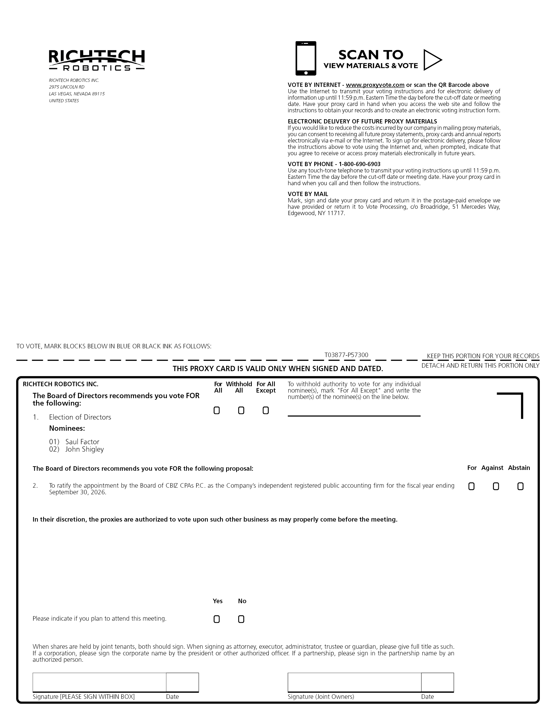
A-1
RICHTECH ROBOTICS INC. 2975 LINCOLN RD LAS VEGAS, NEVADA 89115 UNITED STATES VOTE BY INTERNET - www.proxyvote.com or scan the QR Barcode above Use the Internet to transmit your voting instructions and for electronic delivery of information up until 11:59 p.m. Eastern Time the day before the cut-off date or meeting date. Have your proxy card in hand when you access the web site and follow the instructions to obtain your records and to create an electronic voting instruction form. ELECTRONIC DELIVERY OF FUTURE PROXY MATERIALS If you would like to reduce the costs incurred by our company in mailing proxy materials, you can consent to receiving all future proxy statements, proxy cards and annual reports electronically via e-mail or the Internet. To sign up for electronic delivery, please follow the instructions above to vote using the Internet and, when prompted, indicate that you agree to receive or access proxy materials electronically in future years. VOTE BY PHONE - 1-800-690-6903 Use any touch-tone telephone to transmit your voting instructions up until 11:59 p.m. Eastern Time the day before the cut-off date or meeting date. Have your proxy card in hand when you call and then follow the instructions. VOTE BY MAIL Mark, sign and date your proxy card and return it in the postage-paid envelope we have provided or return it to Vote Processing, c/o Broadridge, 51 Mercedes Way, Edgewood, NY 11717. TO VOTE, MARK BLOCKS BELOW IN BLUE OR BLACK INK AS FOLLOWS: T03877-P57300 KEEP THIS PORTION FOR YOUR RECORDS DETACH AND RETURN THIS PORTION ONLY THIS PROXY CARD IS VALID ONLY WHEN SIGNED AND DATED. RICHTECH ROBOTICS INC. For All Withhold All For All Except To withhold authority to vote for any individual nominee(s), mark “For All Except” and write the number(s) of the nominee(s) on the line below. The Board of Directors recommends you vote FOR the following: 1. Election of Directors Nominees: 01) Saul Factor 02) John Shigley The Board of Directors recommends you vote FOR the following proposal: 2. To ratify the appointment by the Board of CBIZ CPAs P.C. as the Company’s independent registered public accounting firm for the fiscal year ending September 30, 2026. For Against Abstain In their discretion, the proxies are authorized to vote upon such other business as may properly come before the meeting. Please indicate if you plan to attend this meeting. Yes No When shares are held by joint tenants, both should sign. When signing as attorney, executor, administrator, trustee or guardian, please give full title as such. If a corporation, please sign the corporate name by the president or other authorized officer. If a partnership, please sign in the partnership name by an authorized person. Signature [PLEASE SIGN WITHIN BOX] Date Signature (Joint Owners) Date

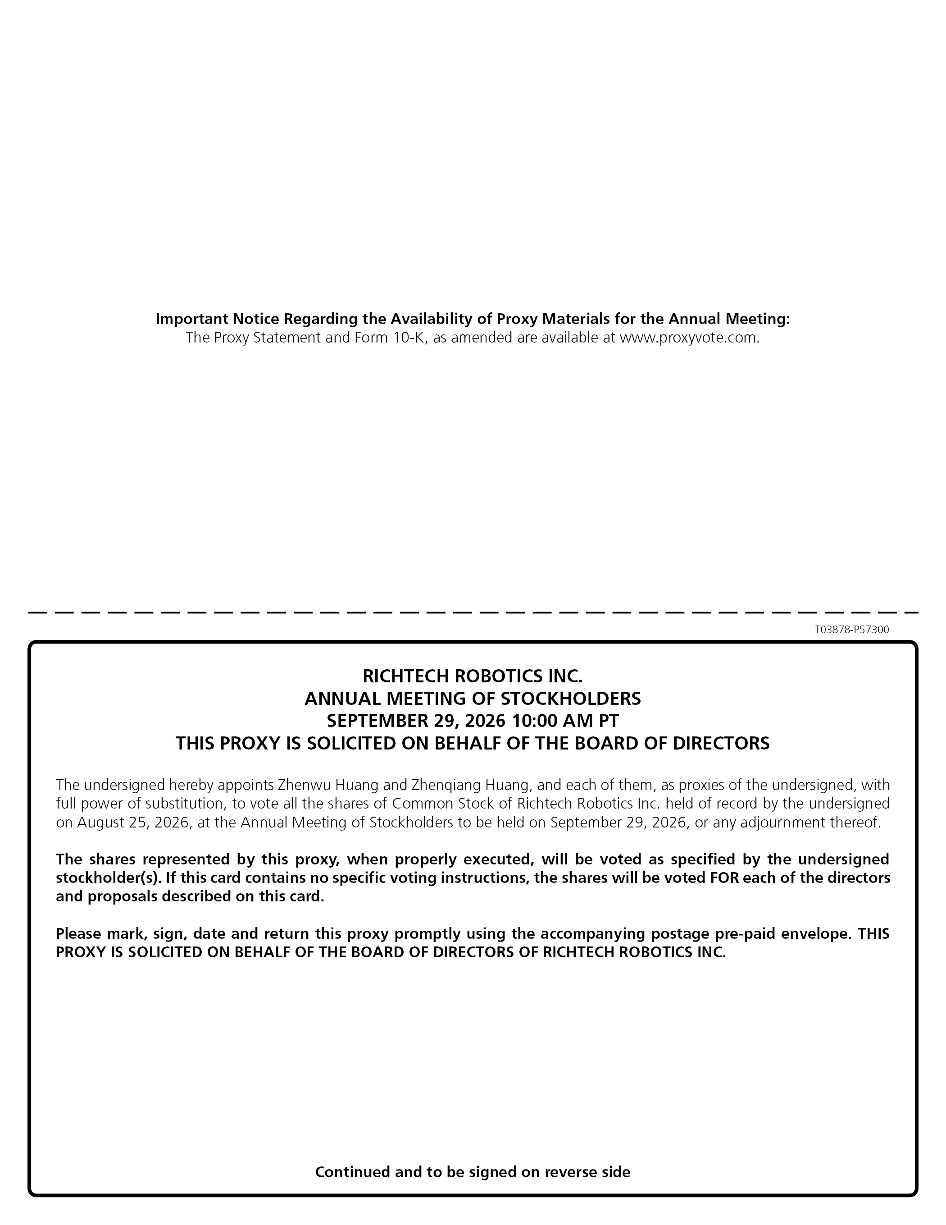
Important Notice Regarding the Availability of Proxy Materials for the Annual Meeting: The Proxy Statement and Form 10-K, as amended are available at www.proxyvote.com. T03878-P57300 RICHTECH ROBOTICS INC. ANNUAL MEETING OF STOCKHOLDERS SEPTEMBER 29, 2026 10:00 AM PT THIS PROXY IS SOLICITED ON BEHALF OF THE BOARD OF DIRECTORS The undersigned hereby appoints Zhenwu Huang and Zhenqiang Huang, and each of them, as proxies of the undersigned, with full power of substitution, to vote all the shares of Common Stock of Richtech Robotics Inc. held of record by the undersigned on August 25, 2026, at the Annual Meeting of Stockholders to be held on September 29, 2026, or any adjournment thereof. The shares represented by this proxy, when properly executed, will be voted as specified by the undersigned stockholder(s). If this card contains no specific voting instructions, the shares will be voted FOR each of the directors and proposals described on this card. Please mark, sign, date and return this proxy promptly using the accompanying postage pre-paid envelope. THIS PROXY IS SOLICITED ON BEHALF OF THE BOARD OF DIRECTORS OF RICHTECH ROBOTICS INC. Continued and to be signed on reverse side
A-2

